**Electronic supplementary information**

**η5-FLUORENYL RHODIUM COMPLEXES:  
ARE THEY A MYTH OR REALITY?**

V. B. Kharitonov,* K. A. Vasilyev, Yu. V. Nelyubina, and D. A. Loginov

*Nesmeyanov Institute of Organoelement Compounds, Russian Academy of Sciences,  
ul. Vavilova 28, str. 1, Moscow, 119334 Russia*

**Table of contents**

General experimental remarks S2

NMR spectra S3

Computational details S4

X-ray diffraction study S9

**General experimental remarks**

All reactions were carried out under an argon atmosphere using distilled solvents. Isolation of the product was carried out in air. [CpRhI2]n [1] and hexadecahydrotetrabenzo[*a*,*c*,*d*,*f*]fluorene [2] were synthesized by the previously published procedures. All other reagents were purchased from Acros or Aldrich and used as received. The 1H and 13C{1H} NMR spectra were recorded on a Varian Inova 400 spectrometer operating at 400 and 101 MHz, respectively. The chemical shifts are given in ppm using the residual solvent signals as an internal standard (nitromethane-*d*3: 4.42 and 61.35 ppm for 1H and 13C{1H} NMR spectra, respectively).

**Preparation of complex 1(SbF6)2**

MeNO2 (1 mL) was added to a mixture of the iodide complex [CpRhI2]n (50 mg, 0.118 mmol), hexadecahydrotetrabenzo[*a*,*c*,*d*,*f*]fluorene (54 mg, 0.142 mmol, 1.2 equiv.), and AgSbF6 (81 mg, 0.236 mmol, 2 equiv.). The reaction mixture was vigorously stirred for 2 h, and the precipitate of AgI was centrifuged off. Then, an excess of ether was added. The precipitate that formed was reprecipitated twice from nitromethane by ether. Then the precipitate was washed with cold dichloromethane (2×2 mL) to remove [Cp2Rh]SbF6. Compound **1**(SbF6)2 was obtained as a lemon-yellow solid. Yield is 76 mg (63%). Melting point was not measured because decomposition occurs at 89 ºC in air.

**[CpRh(η6-hexadecahydrotetrabenzo[*a*,*c*,*d*,*f*] fluorene)](SbF6)2 (1(SbF6)2)**



1H NMR (400 MHz, CD3NO2): δ 6.36 (s, 5H), 4.12 (q, J = 23.9 Hz, 2H), 3.66 – 3.50 (m, 2H), 3.29 – 2.99 (m, 7H), 2.82 – 2.73 (m, 6H), 2.19 – 2.06 (m, 9H), 1.95 – 1.78 (m, 8H), 1.66 – 1.54 (m, 1H).

13C{1H} NMR (101 MHz, CD3NO2) δ 144.5, 144.3, 137.7, 135.5, 132.2, 129.2, 119.0 (d, J = 5.3 Hz), 118.9 (d, J = 4.4 Hz), 118.3 (d, J = 4.3 Hz), 117.2 (d, J = 4.7 Hz), 116.0 (d, J = 4.5 Hz), 95.6 (d, J = 7.2 Hz), 35.6, 33.9, 33.4, 27.0, 27.0, 26.7, 26.3, 26.1, 22.4, 22.3, 22.2, 21.7, 21.6, 21.0, 20.4, 20.1. Anal. Calcd for C34H39F12RhSb2: C, 39.95; H, 3.85. Found: C, 39.86; H, 3.99%.

**NMR spectra**

**1H NMR (400 MHz) spectrum of 1(SbF6)2 in CD3NO2**

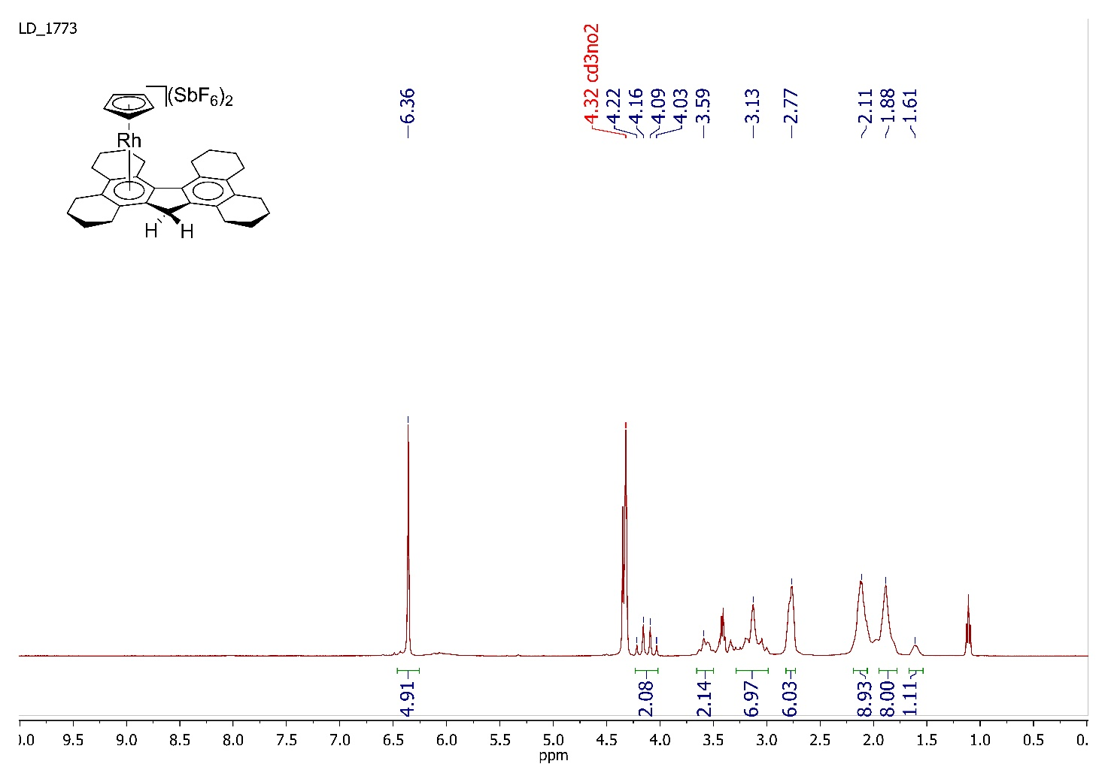

**13C{1H} NMR (101 MHz) spectrum of 1(SbF6)2 in CD3NO2**

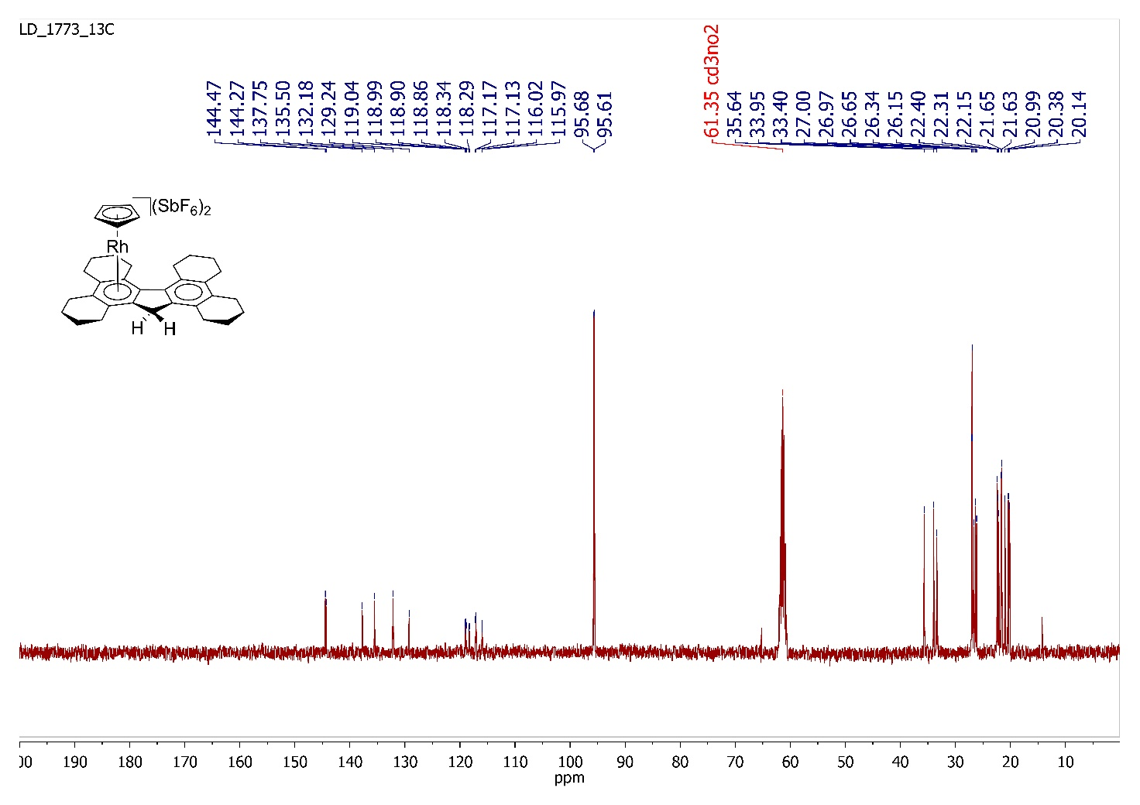

**Computational details**

All calculations were performed using Gaussian 09 software (revision D.01) [3] at the M06L(D3)/LANL2DZ level [4, 5] with corrections for solvation in methanol (the CPCM model implemented in the Gaussian 09 program). Geometry optimizations were performed with convergence options SCF=Tight and Grid=FineGrid.

To estimate the stability of the fluorenyl complexes, we calculated total free energies (Δ*Gr*) at the temperature of 298.150 K and the pressure of 1.00000 Atm for the reaction of [СpRh(η5-fluorenyl)]+ complex with two water molecules. Similar reactions were calculated for complexes [Сp2Rh]+ and [СpRh(η5-indenyl)]+ for comparison (Table S1). It was found that only for the fluorenyl derivative the η5🡪η1 rearrangement is exergonic.

**Table S1.** Sums of electronic and thermal free energies for the starting compounds (*E*SC) and the adducts with two water molecules (*E*AW), as well as total free energies (*Gr*) for the reaction of rhodium complexes with water

|  |  |  |  |
| --- | --- | --- | --- |
| Ligand | *E*SC  (in hartree) | *E*AW  (in hartree) | Δ*Gr*  (in kcal·mol–1) |
| Cyclopentadienyl | –649.036876 | –648.996058 | –25.6 |
| Indenyl | –802.590384 | –802.569280 | –13.24 |
| Fluorenyl | –956.145740 | –956.148263 | 1.58 |

**[CpRh(η5-cyclopentadienyl)]+ ·2H2O**

45 -0.014043000 0.217619000 -0.300960000

6 0.682916000 1.713718000 1.201935000

6 -0.755108000 1.616913000 1.270519000

6 -1.290933000 2.024537000 -0.006290000

6 -0.183999000 2.372931000 -0.864189000

1 -0.254893000 2.714916000 -1.882732000

6 1.035971000 2.179779000 -0.117701000

6 -1.110189000 -1.496471000 -1.204424000

1 -2.148047000 -1.448591000 -1.489744000

6 -0.606770000 -1.893212000 0.090240000

1 -1.229150000 -2.146242000 0.935401000

6 0.833689000 -1.811055000 0.051876000

1 1.523364000 -1.990061000 0.863539000

6 1.218519000 -1.363426000 -1.267235000

1 2.227461000 -1.196701000 -1.607016000

6 0.017455000 -1.168524000 -2.044543000

1 -0.028448000 -0.838436000 -3.068495000

8 3.371272000 -1.161376000 1.671643000

1 3.629282000 -0.413098000 1.102975000

1 4.119246000 -1.373188000 2.259084000

8 -3.195871000 -1.455679000 1.691732000

1 -3.897369000 -1.710190000 2.318449000

1 -3.506347000 -0.687060000 1.179044000

1 2.034785000 2.350809000 -0.482224000

1 1.371655000 1.476426000 1.995424000

1 -1.328206000 1.296076000 2.124036000

1 -2.333899000 2.057796000 -0.272660000

**[CpRh(η1-cyclopentadienyl)(H2O)2]+**

45 -0.455813000 0.191450000 0.037913000

6 2.968379000 -1.130367000 0.495426000

6 3.367409000 0.138105000 -0.112223000

6 2.421628000 0.497842000 -1.053999000

6 1.354221000 -0.510626000 -1.056885000

1 0.863897000 -0.778112000 -1.990563000

6 1.788650000 -1.546351000 -0.100555000

6 -2.154219000 -0.146217000 -1.278643000

1 -2.215886000 0.208162000 -2.293543000

6 -2.711643000 0.524990000 -0.099251000

1 -3.173754000 1.498773000 -0.099662000

6 -2.469619000 -0.284704000 1.034523000

1 -2.710894000 -0.043979000 2.056053000

6 -1.738791000 -1.471040000 0.590282000

1 -1.410637000 -2.281790000 1.219492000

6 -1.631614000 -1.418485000 -0.849095000

1 -1.172828000 -2.164479000 -1.476761000

8 0.247062000 2.268098000 -0.178528000

1 1.103495000 2.397877000 -0.630665000

1 -0.382059000 2.973751000 -0.414544000

8 0.791866000 0.515384000 1.813253000

1 1.644911000 0.020580000 1.770684000

1 0.953823000 1.474816000 1.913809000

1 4.267158000 0.685759000 0.132747000

1 2.487206000 1.334397000 -1.738776000

1 3.526025000 -1.662145000 1.254186000

1 1.253275000 -2.465586000 0.096174000

**[CpRh(η5-indenyl)]+ ·2H2O**

45 -0.524394000 -0.078024000 -0.381950000

6 -0.096587000 -1.826211000 0.912218000

6 1.196439000 -1.190793000 0.727451000

6 2.117471000 -0.609518000 1.641646000

1 1.906824000 -0.605963000 2.703279000

6 3.293736000 -0.073787000 1.139283000

1 4.020205000 0.352526000 1.819735000

6 3.581053000 -0.075324000 -0.263811000

1 4.514983000 0.352807000 -0.604919000

6 2.698459000 -0.617967000 -1.184316000

1 2.923981000 -0.621870000 -2.242792000

6 1.491918000 -1.197229000 -0.703384000

6 0.380552000 -1.842090000 -1.379752000

1 0.306594000 -2.025246000 -2.439019000

6 -0.553764000 -2.287744000 -0.375547000

6 -0.637279000 2.044449000 -1.102158000

1 0.200733000 2.565525000 -1.535405000

6 -0.972860000 2.010210000 0.310814000

1 -0.395290000 2.491643000 1.085670000

6 -2.146678000 1.201303000 0.471069000

1 -2.638999000 0.923265000 1.391313000

6 -2.526202000 0.712901000 -0.840837000

1 -3.363325000 0.068961000 -1.055761000

6 -1.604006000 1.259618000 -1.814982000

1 -1.631520000 1.089390000 -2.877781000

8 -3.575057000 -0.929101000 2.192668000

1 -3.551063000 -1.615651000 1.501187000

1 -4.108822000 -1.262671000 2.936756000

8 1.767460000 2.944953000 1.236254000

1 2.508026000 3.337969000 1.733777000

1 2.082688000 2.120069000 0.819154000

1 -1.459492000 -2.841126000 -0.560814000

1 -0.590517000 -1.992278000 1.855835000

**[CpRh(η1-indenyl)(H2O)2]+**

45 -1.088555000 0.173011000 0.103735000

6 1.906539000 -1.624969000 -0.604970000

1 1.187519000 -2.329934000 -1.009852000

6 3.067589000 -2.091579000 0.038594000

1 3.242304000 -3.157907000 0.121894000

6 4.006279000 -1.189276000 0.579076000

1 4.888422000 -1.572254000 1.078778000

6 3.814687000 0.199487000 0.469207000

1 4.546294000 0.889497000 0.874587000

6 2.665461000 0.672981000 -0.185871000

6 2.215001000 2.026655000 -0.504303000

6 1.021250000 1.947412000 -1.183885000

6 0.576495000 0.543383000 -1.281224000

1 0.114851000 0.215024000 -2.211232000

6 1.699577000 -0.243760000 -0.712314000

6 -2.776119000 -0.370173000 -1.152830000

1 -3.114232000 0.200901000 -2.000886000

6 -3.345520000 -0.314144000 0.200989000

1 -4.092551000 0.390892000 0.528498000

6 -2.687455000 -1.263762000 1.007012000

1 -2.838717000 -1.429100000 2.060394000

6 -1.675261000 -1.923365000 0.178232000

1 -0.999518000 -2.695325000 0.510008000

6 -1.815003000 -1.445391000 -1.175097000

1 -1.253644000 -1.783645000 -2.030038000

8 -1.149619000 2.302292000 0.705162000

1 -0.515009000 2.912523000 0.279834000

1 -2.015476000 2.733832000 0.823276000

8 0.296413000 0.341020000 1.826612000

1 1.257676000 0.234609000 1.668791000

1 0.115642000 1.209378000 2.240406000

1 2.760005000 2.930055000 -0.266285000

1 0.485927000 2.778452000 -1.626146000

**[CpRh(η5-fluorenyl)]+ ·2H2O**

45 -0.000188000 0.526103000 -0.416386000

6 -2.561961000 -1.378805000 -1.291542000

1 -2.893840000 -1.246785000 -2.313354000

6 -3.466020000 -1.593085000 -0.264050000

1 -4.526031000 -1.628174000 -0.480942000

6 -3.031419000 -1.780653000 1.086644000

1 -3.773458000 -1.962134000 1.854182000

6 -1.685764000 -1.749022000 1.428220000

1 -1.368418000 -1.900978000 2.452323000

6 -0.731063000 -1.541369000 0.398742000

6 0.730230000 -1.541459000 0.399331000

6 1.684025000 -1.749284000 1.429596000

1 1.365802000 -1.901055000 2.453452000

6 3.029941000 -1.781318000 1.089103000

1 3.771319000 -1.962877000 1.857260000

6 3.465669000 -1.594015000 -0.261256000

1 4.525845000 -1.629488000 -0.477302000

6 2.562484000 -1.379560000 -1.289510000

1 2.895231000 -1.247751000 -2.311063000

6 1.173452000 -1.361914000 -0.979937000

6 0.000508000 -1.154365000 -1.811605000

1 0.000971000 -1.022753000 -2.881704000

6 -1.173151000 -1.361661000 -0.980874000

6 1.157777000 2.384964000 -0.704110000

1 2.184288000 2.372703000 -1.033364000

6 0.715023000 2.368807000 0.684038000

1 1.381126000 2.315788000 1.531710000

6 -0.709634000 2.368128000 0.689751000

1 -1.369014000 2.314718000 1.542542000

6 -1.163223000 2.383267000 -0.694675000

1 -2.192230000 2.369278000 -1.015950000

6 -0.006149000 2.438906000 -1.553083000

1 -0.010619000 2.476225000 -2.629044000

8 -3.389686000 1.453158000 1.787875000

1 -3.172271000 0.595053000 1.373086000

1 -4.187308000 1.335148000 2.335791000

8 3.397198000 1.453500000 1.779425000

1 4.194237000 1.334101000 2.327882000

1 3.178403000 0.595694000 1.364760000

**[CpRh(η1-fluorenyl)(H2O)2]+**

45 -1.356483000 0.271272000 0.193629000

6 0.501360000 -2.599144000 -0.879713000

1 -0.432216000 -2.784189000 -1.401233000

6 1.244736000 -3.674114000 -0.360673000

1 0.882172000 -4.687428000 -0.487243000

6 2.454642000 -3.448955000 0.326344000

1 3.007468000 -4.290800000 0.726276000

6 2.953547000 -2.145233000 0.490339000

1 3.892765000 -1.979868000 1.007077000

6 2.221925000 -1.070457000 -0.035029000

6 2.504505000 0.366410000 -0.072457000

6 3.596039000 1.110470000 0.393710000

1 4.408739000 0.630725000 0.928306000

6 3.634587000 2.493714000 0.142831000

1 4.473557000 3.081135000 0.496275000

6 2.601516000 3.122422000 -0.579179000

1 2.658000000 4.185286000 -0.781772000

6 1.496583000 2.382061000 -1.043078000

1 0.710593000 2.868272000 -1.613673000

6 1.439647000 1.004005000 -0.776748000

6 0.392014000 0.011600000 -1.107156000

1 -0.085243000 0.092491000 -2.083264000

6 0.984043000 -1.293817000 -0.712594000

6 -3.001698000 0.841023000 -1.109703000

1 -2.966808000 1.658308000 -1.810340000

6 -3.591815000 0.892047000 0.236664000

1 -3.953767000 1.786067000 0.718501000

6 -3.511845000 -0.389836000 0.809899000

1 -3.803962000 -0.667584000 1.808738000

6 -2.855886000 -1.272185000 -0.161060000

1 -2.655944000 -2.321515000 -0.015784000

6 -2.652759000 -0.531098000 -1.380281000

1 -2.244609000 -0.917620000 -2.299419000

8 -0.451620000 2.035787000 1.167240000

1 0.266386000 2.508301000 0.688746000

1 -1.059718000 2.669855000 1.590326000

8 -0.198067000 -0.516576000 1.908440000

1 0.444047000 -1.243748000 1.789768000

1 0.230928000 0.257897000 2.327261000

**X-ray diffraction study**

Crystals of **1**(SbF6)2 were grown by slow interdiffusion of a two-phase system containing ether and a solution of the compound in nitromethane. X-ray diffraction data were collected at 120 K with a Bruker APEX2 DUO CCD diffractometer, using graphite monochromated Mo-Kα radiation (l = 0.71073 Å, ω-scans). Using Olex2 [6], the structure was solved with the ShelXT [7] structure solution program using Intrinsic Phasing and refined with the XL [8] refinement package using Least-Squares minimization against F2 in the anisotropic approximation for non-hydrogen atoms. Positions of hydrogen atoms were calculated, and they were refined in the isotropic approximation in the riding model. Crystal data and structure refinement parameters are given in Table S2. CCDC 2389361 (**1**(SbF6)2) contain the supplementary crystallographic information for this paper.



**Figure S1**. General view of **1**(SbF6)2 in the representation of atoms as 50% probability ellipsoids; hydrogen atoms are omitted. Bond lengths [Å]: C13 - C14 1.57(3), C14 - C15 1.509(19), C15 - C16 1.67(4),C16 - C16A 1.51(4), C16A - C16B 1.57(3), C16A - Rh1 2.39(3), C16B - C17 1.48(3), C16B - Rh1 2.32(2), C17 - C17A 1.52(3), C17A - C17B 1.21(3), C1 - C2 1.34(4), C1 - C17B 1.53(4), C2 - C3 1.48(2), C18 - C19 1.42(2), C3 - C4 1.40(5), C18 - C22 1.39(2), C4 - C4A 1.60(4), C18 - Rh1 2.08(4), C4A - C4B 1.37(3), C4A - C17B 1.43(3), C19 - C20 1.38(3), C19 - Rh1 2.16(4), C4B - C5 1.65(3), C4B - C8A 1.38(2), C20 - C21 1.45(2), C20 - Rh1 2.18(2),C5 - C6 1.36(3), C6 - C7 1.50(2), C21 - C22 1.46(2), C7 - C8 1.63(4), C21 - Rh1 2.10(3), C8 - C8A 1.56(3), C8A - C8B 1.34(3), C22 - Rh1 1.85(3), C8B - C8C 1.47(2), C8B - C17A 1.35(3), C8C - C8D 1.567(19), C8C - C16B 1.52(3), C8C - Rh1 2.30(2), C8D - C9 1.54(3), C8D - C12A 1.4191, C8D - Rh1 2.2587, C9 - C10 1.46(4), C10 - C11 1.482(17), C11 - C12 1.69(2), C12 - C12A 1.31(3), C12A - C12B 1.50(3), C12A - Rh1 2.3260, C12B - C13 1.44(4), C12B - C16A 1.37(4), C12B - Rh1 2.29(3).

**Table S2.** Crystal data and structure refinement parameters for complex **1**(SbF6)2

|  |  |
| --- | --- |
|  | **1**(SbF6)2 |
| Formula unit | C34H39F11RhSb2 |
| Formula weight | 1003.06 |
| Crystal system | Orthorhombic |
| Space group | Pca21 |
| Z | 4 |
| a, Å | 25.243(4) |
| b, Å | 10.3847(14) |
| c, Å | 14.951(2) |
| α, ° | 90 |
| β, ° | 90 |
| γ, ° | 90 |
| V, Å3 | 3919.3(9) |
| *D*calc (g cm−1) | 1.700 |
| Linear absorption, *μ* (cm−1) | 18.59 |
| F(000) | 1956 |
| 2Θmax, ° | 50 |
| Reflections measured | 31902 |
| Independent reflections | 6886 |
| Observed reflections [*I* > 2σ(*I*)] | 4628 |
| Parameters | 425 |
| R1 | 0.0722 |
| wR2 | 0.1977 |
| GOOF | 1.048 |
| Δ*ρ*max/Δ*ρ*min (e Å−3) | 3.052/–2.397 |

**References**

1. D. A. Loginov, M. M. Vinogradov, Z. A. Starikova, P. V. Petrovskii, A. R. Kudinov, *Russ*. *Chem*. *Bull*., **2004**, *53*, 1949–1953. DOI: 10.1007/s11172-005-0054-5

2. P. V. Ivchenko, I. E. Nifant'ev, V. A. Ezersky, A. V. Churakov, *J. Organomet. Chem.*, **2011**, *696*, 1931–1934. DOI: [10.1016/j.jorganchem.2010.10.050](https://doi.org/10.1016/j.jorganchem.2010.10.050)

3. M. J. Frisch, G. W. Trucks, H. B. Schlegel, G. E. Scuseria, M. A. Robb, J. R. Cheeseman, G. Scalmani, V. Barone, G. A. Petersson, H. Nakatsuji, X. Li, M. Caricato, A. Marenich, J. Bloino, B. G. Janesko, R. Gomperts, B. Mennucci, H. P. Hratchian, J. V. Ortiz, A. F. Izmaylov, J. L. Sonnenberg, D. Williams-Young, F. Ding, F. Lipparini, F. Egidi, J. Goings, B. Peng, A. Petrone, T. Henderson, D. Ranasinghe, V. G. Zakrzewski, J. Gao, N. Rega, G. Zheng, W. Liang, M. Hada, M. Ehara, K. Toyota, R. Fukuda, J. Hasegawa, M. Ishida, T. Nakajima, Y. Honda, O. Kitao, H. Nakai, T. Vreven, K. Throssell, J. A. Montgomery Jr., J. E. Peralta, F. Ogliaro, M. Bearpark, J. J. Heyd, E. Brothers, K. N. Kudin, V. N. Staroverov, T. Keith, R. Kobayashi, J. Normand, K. Raghavachari, A. Rendell, J. C. Burant, S. S. Iyengar, J. Tomasi, M. Cossi, J. M. Millam, M. Klene, C. Adamo, R. Cammi, J. W. Ochterski, R. L. Martin, K. Morokuma, O. Farkas, J. B. Foresman, D. J. Fox, Gaussian 09, Revision D.01.01, Gaussian, Inc., Wallingford CT, **2016**.

4. Y. Zhao, D. G. Truhlar, *J. Chem. Phys.,* **2006**, *125*, 194101. DOI: 10.1063/1.2370993

5. M. Kumar, V. R. Chaudhari, B. Subramaniam, T. A. Jackson, *Organometallics*, **2014**, *33*, 4183–4191. DOI: 10.1021/om9705214

6. O. V. Dolomanov, L. J. Bourhis, R. J. Gildea, J. A. K. Howard, H. Puschmann, *J. Appl. Crystallogr.*, **2009**, *42*, 339–341. DOI: 10.1107/S0021889808042726

7. G. M. Sheldrick, *Acta Crystallogr. A: Found. Adv*., **2015**, *71*, 3–8. DOI: 10.1107/S2053273314026370

8. G. M. Sheldrick, *Acta Crystallogr*., *Sect. A: Found. Crystallogr*., **2008**, *64*, 112–122. DOI: 10.1107/S0108767307043930